ISRAEL VIBRATION
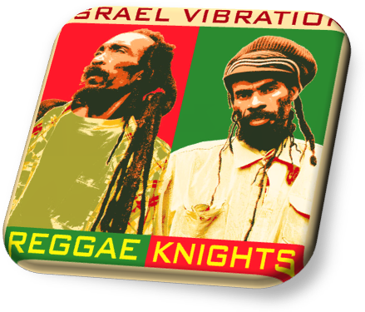
REGGAE KNIGHTS – BIOGRAPHY Novembre 2010

Recorded in Jimmy Cliff's studio (Sun Power Productions) in Kingston, the opus 2010 of Israel Vibration is a new important step in the discography of the band !
Our " Knights of the Reggae " still défend the traditional values of "Roots" since their debut in 1976 and them famous single " Bad Intention " which we find here recording for the first time on an album ! (He was only release in single).

For the production, they surrounded themselves with their faithful sound engineer Christopher Daley (which produced in particular in 2009 the album of Burning Spear crowned with Grammy!), of Dean Fraser and Steve Golding (Original Roots Radics) for the arrangements and respectively for the artistic direction of brass instruments and guitars (magnificent chorus played by Golding). It is the vocalist Grub Cooper which orchestrated choirs.
The musicians are a mixe of former and new generations allowed to bring to fresh spirit and maturity in 14 pieces ! We find logically the ' Roots Radics ' Flaba Holt (bass), Obeah (keyboard) and Golding. The newcomers are the formations drum & bass, guitar, keyboards stemming from the backing ' Blak Soil Band ' (who turn with Tarrus Riley).
We also find there in guest Robbie Sheakspeare on 4 tracks
The album brings us in the Jamaica such as we love it, determinedly roots with "Bad Intention" in introduction, as is this song in their career, and also a return towards the roots of the mento with the track " Cantankerous " where they describe the perception of people of the island by the English colonists.

Wiss and Skelly remains faithful to their ideas and their line of conduct determinedly pacifist and turned into the love of people and life with all the same new influences as in the song " Original Gangster " where they hijack the dancehall to criticize the lifestyle of a generation in loss of marks!
We shall appreciate as usual the sweetness of the voice of Wiss contrasting with the stamp more ruff of Skelly as much as its own life!
European Public will be lucky to see a new tour of the group throughout November with a gréât night in Paris at The « Cabaret Sauvage » on November 1st!
www.mediacom-agency.com

ISRAEL VIBRATION
REGGAE KNIGHTS – Novembre 2010

TOUR 2010 :

29 / 10 - Tulle - Festival Oh les chœurs
30 / 10 - Sauveterre de Rouergue - Roots’ergue festival
31 / 10 - Rilieux La Pape - MJC
1er / 11 - Paris - Cabaret Sauvage
3 / 11 - Strasbourg - La Laiterie
6 / 11 - Anvers (Belgique)
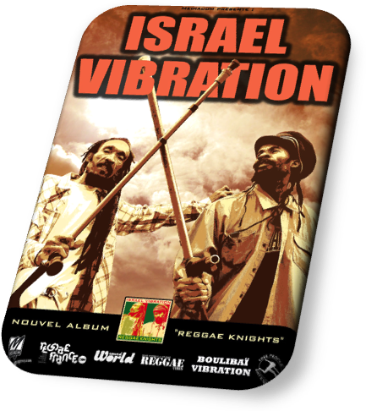
7 / 11 - Lille - tba
9 / 11 - Limoges - CC John Lennon
10 / 11 - Toulouse - Le Bikini
11 / 11 - Aarau - KiFF (Suisse)
12 / 11 - Lausanne -Métropop Fest (Suisse)
13 / 11 - Beauvais - L'ouvre boite
14 / 11 - La Rochelle - Georges brassens
16 / 11 - Bordeaux - Théatre Barbey
17 / 11 – Le havre – Magic Mirror
18 / 11 - Brest - La Carène
19 / 11 - Saint-Malo - L'Omnibus
20 / 11 - Saint Lo - Le Normandy
22 / 11 - Angers - Le Chabada
23 / 11 - Montpellier - Le Rockstore
27 / 11 - Biarritz - L’Atabal
28 / 11 - Marseille - L’Espace julien
29 / 11 - Avignon - Les Passagers du Zinc
30 / 11 - Issoudun - La Boite à Musique
4 / 12 - Nancy - L’Autre Canal - JDM Fest

CONTACT BOOKING : claire@mediacom-agency.com
CONTACT PROMO : promo@mediacom-agency.com

www.mediacom-agency.com

