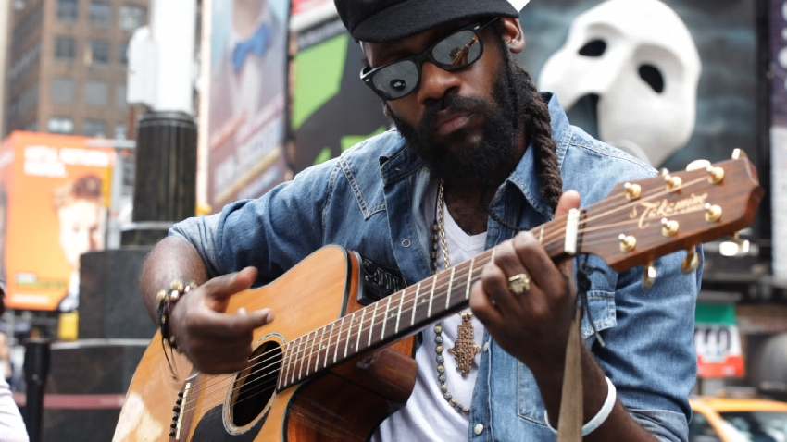

There is no doubt about Tarrus Riley being THE Jamaican reggae star of our times, and he obviously is the artist who deserves the most the title of heir of roots and conscious Reggae!
Son of Jimmy Riley, a famous Jamaican singer of the 70s, Tarrus recorded his first single as a teenager and started as a DJ. Produced by the legendary saxophonist Dean Fraser, his debut album Challenges (2004) was a decisive step into the Jamaican scene. With the international hits She's Royal and Beware, released on the album Parables (2007), Tarrus became one of the most promising artists of the island. Riley came back in 2009 with the album Contagious and its massive hit Good Girl Gone Bad, featuring Konshens, that led him to break the international charts and established him as the Jamaican artist of our times.
While still working with Dean Fraser, the singer did not hesitate to collaborate for this album with other producers such as Shane Brown, John John, Tarik "Russian" Johnston or the Londoner Chris Peckings, and to explore new flavors of music. The result was amazing and Tarrus Riley signed there a landmark album including a cover of Michael Jackson (Human Nature) and featurings with Etana and Duane Stephenson, Vybz Kartel and Demarco (Let Peace Reign, Herbs Promotion).
With Mecoustic, his fourth album which was released in April 2012, Tarrus Riley delivered this time a more acoustic album and we can discover through it a different facet of his usual work and Reggae/dancehall vibe. Its fine-produced sound doped by the artist subtle voice make this album a treasure and the fans can appreciate the covers of some of his best hits.
On stage, backed by Dean Fraser & the Blak Soil Band during his last three tours all over Europe, his live performances at the biggest festivals (Printemps de Bourges, Artefact in 2012, Paleo Festival, Dour and Roskilde Festival in 2011 ...), were widely acclaimed.
Tarrus will be on tour again in August 2012, and the release of his next and fifth album will soon follow early 2013 ... the 32 years-old artist keeps impressing us !!

